Introduction to Statistics

Question 1. There is an assumption that there is no significant difference between boys and girls with respect to intelligence. Tests are conducted on two groups and the following are the observations
Ans:
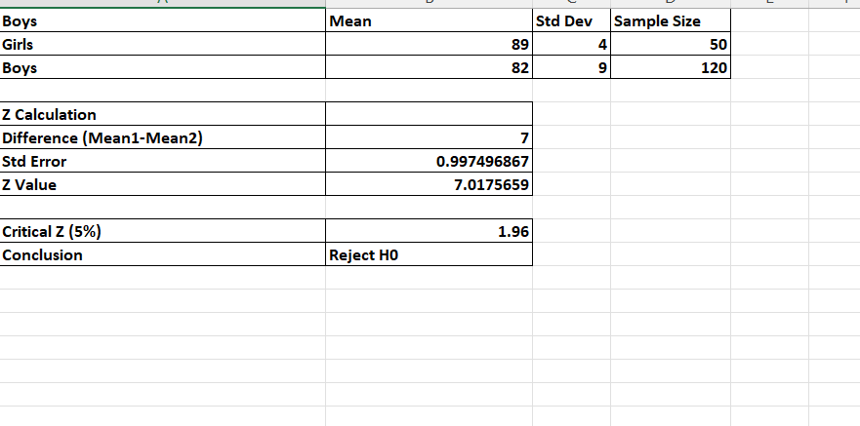

Question 2. Analyze the below data and tell whether you can conclude that smoking causes cancer or not?

Ans:
